**Reneal 2024A Box and Project Notes**

**Version 1**

IMPORTANT NOTES

1. Twelve new schools:
   1. Lindi Region: Lucas Malia, Nkowe, Hawa Mchopa, Ruangwa, and Mbekenyera
   2. Mara Region: Butiama, Butuguri, Kiabakari, Kiagata, and Bumangi
   3. Kilimanjaro Region: Kiboriloni and Ifati
2. There are no mice for the laptops in this shipment. The ecolevy was too expensive to ship mice to the schools. There is only one mouse per school, for the server.
3. Two boxes (E and KK) are sealed by Bureau Veritas Inspection Tape. Do not remove or disturb this tape until the items are at the school.
4. Please collect any equipment donated by Apto that has failed and save it at the RO. We must return any dead items to Apto Solutions for recycling if we cannot fix them.

Summary of Box Contents

1. Here is the organization of the boxes:
   1. Boxes A-X have laptops/adapters, and a keyboard and a mouse for each of the 12 new schools. There are two boxes per new school (total of 24 boxes).
   2. Boxes GG, HH, and II have 4 monitor screens/stands/bases/VGA cables/power cables per box (one for each school)
   3. Box JJ has 4 monitor screens/stands/bases/VGA cables/power cables (spares)
   4. Box KK has 2 monitor screens/stands/bases/VGA cables/power cables (spares), 3 spare keyboards, and a box of Team supplies.
   5. The spare monitors, cables, and keyboards should go to Ashura’s warehouse.
   6. Boxes AA, BB, CC, DD, EE, and FF have the following:
      1. Servers and network switches for the 12 new schools (two per box).
      2. The power cable for the server and the sys admin manual are inside each server box. Two copies of the donation letter are inside the sys admin manual. For Kiagata and Bumangi, there are also instructions for the Dell E5470 laptops (how to boot them if the CMOS battery is dead).
2. All monitors have VGA cables in this shipment.
3. The following boxes have all of the equipment for the 12 new schools:
   1. Lucas Malia Secondary School: A, B, part of AA, part of GG
   2. Nkowe Secondary School: C, D, part of AA, part of GG
   3. Hawa Mchopa Secondary School: E, F, part of BB, part of GG
   4. Ruangwa Secondary School: G, H, part of BB, part of GG
   5. Mbekenyera Secondary School: I, J, part of CC, part of HH
   6. Butiama Secondary School: K, L, part of CC, part of HH
   7. Butuguri Secondary School: M, N, part of DD, part of HH
   8. Kiabakari Secondary School: O, P, part DD, part of HH
   9. Kiagata Secondary School: Q, R, part of EE, part of II
   10. Bumangi Secondary School, S, T, part of EE, part of II
   11. Kiboriloni Secondary School, U, V, part of FF, part of II
   12. Ifati Secondary School, W, X, part of FF, part of II
4. Team supplies are in Box KK.

The Team Supplies box has 8 bags of RJ45 connectors (100 connectors/bag).

* Six of the bags of RJ45 connectors are for the 12 new schools
* Two of the bags of RJ45 connectors are to share between the Team members to do repairs

There is a bag of cable zip ties for installing at the new schools.

There is a new connection cable for the Habari Node server (Erick will hold this).

Arusha Equipment

|  |  |  |
| --- | --- | --- |
| **Item** | **Purchased** | **Destination** |
| Uninterruptible power supply (UPS) | 12 | All schools |
| Voltage stabilizer, 500VA | 12 | All schools |
| Power universal extensions (5 outlets) | 60 | 5 each for all schools |

PLEASE NOTE: We will purchase 6 boxes of UTP cable.

Installation Notes

Here is a list of what you will need at each new school being installed: server, power cord for server, sysadmin manual and donation letters, keyboard, monitor screen, monitor stand (2 pieces), power and video cables for monitor, network switch and power cord, 20 laptops, 20 laptop adapters, 1 mouse, UPS, 3 special UPS cords OR a multiplug (for server, monitor, and network switch), voltage stabilizer, 5 extensions, Cat6 cable, RJ45 connectors, zip ties, blue tape, pens, cable clips, screws for mounting the switch, hammer and drill, your personal supplies and tools, power meter, and Reneal T-shirts.

1. Please use Erick’s installation checklist to make sure all steps are completed and you gather all the needed information about the new school plus the signed donation letters.
2. PLEASE NOTE: UPS should be charged for 12 hours before it is used the first time.
3. Before you plug anything in, check the computer room voltage with the power meter to make sure it is around 220 volts and stable.
4. Neal turned off the power supply switch on each server, so you will need to turn it on before you start the server.
5. We did not put security stickers on the server this time, but please do not open the server unless you experience problems.

If the server does not start properly, take off the cover and check the power connectors to the motherboard, check any SATA cables, make sure the RAM is inserted fully, and check the network cards to make sure they are inserted completely. Most of the storage is now SSD attached to the motherboard, so they should not need to be checked since they are firmly attached.

1. I have the specifications for all of the laptops in a spreadsheet. Please leave the blue tape with the number on the laptop, for identification. “AS” with a number means the laptop/adapter was donated by Apto Solutions.

Laptop Notes

There are Dell Laptops for 10 schools and HP laptops for 2 schools.

All of the Dell adapters should work with any Dell laptop, so the adapters are not labeled with a number. For some Dell laptops, you may see a message about the power adapter not providing enough power to charge the battery, or that it can’t identify the power adapter. Please just hit F3, which will disable future warnings. Then hit F1 to continue the boot.

Dell E5470 Laptop with dead CMOS battery (Kiagata and Bumangi)

Never try to change the CMOS battery for the Dell E5470. It is very difficult.

For most of E5470 laptops with a dead CMOS, you can just do “F1” on boot. However there are 2 units (AS-1504 and AS-1533) that seem to have a more recent BIOS and will boot to UEFI and not the network. It will take an extra step to boot these computers. Please read the special instructions below and share with the SUs. There is also a copy of these special instructions in the sysadmin manual for these two schools and also in the box. There is also a video to watch, that I will send on WhatsApp.

A laptop with a dead CMOS battery will take a long time to start. The SU can just turn these on and then go do other things, so they don’t have to wait.

Then it will show this screen. You know that the CMOS battery is dead, because the laptop does not know the time or date.

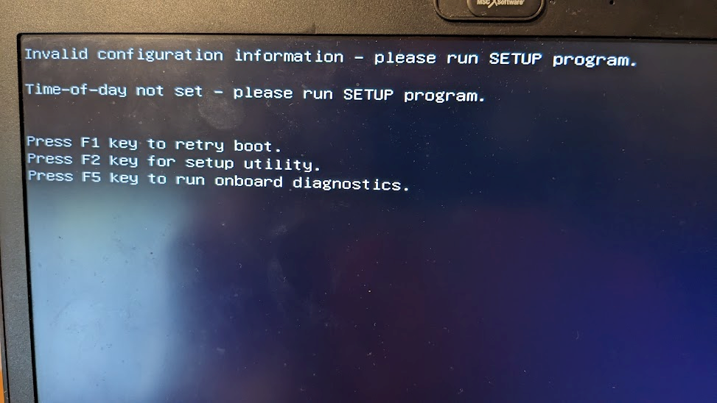

Press F1 to retry the boot

For most of these laptops with a dead CMOS battery, the next screen you see will be this, and the boot has been successful

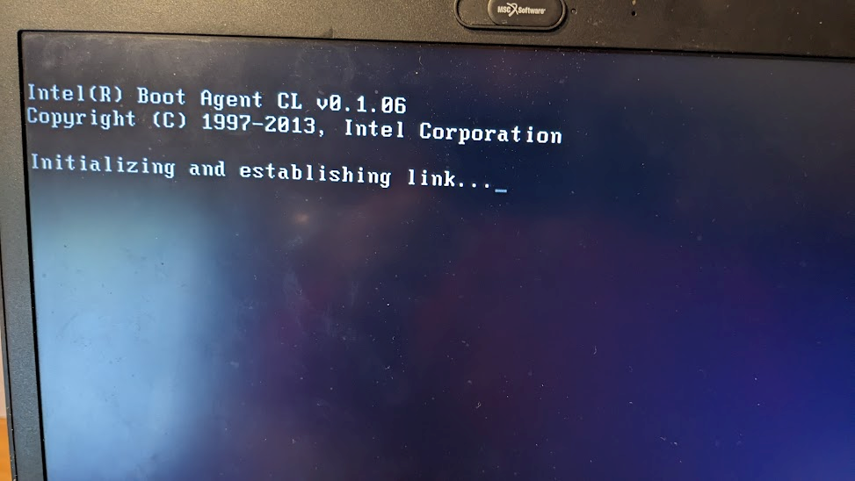

However, there are 2 E5470 units (AS-1504 and AS-1533) that seem a more recent BIOS and will boot to UEFI and not the network. For these units, the screen below comes up. For some reason, it has changed to “UEFI” mode instead of Legacy BIOS. You will need to do more steps to do a successful boot. (This might happen for other units.)

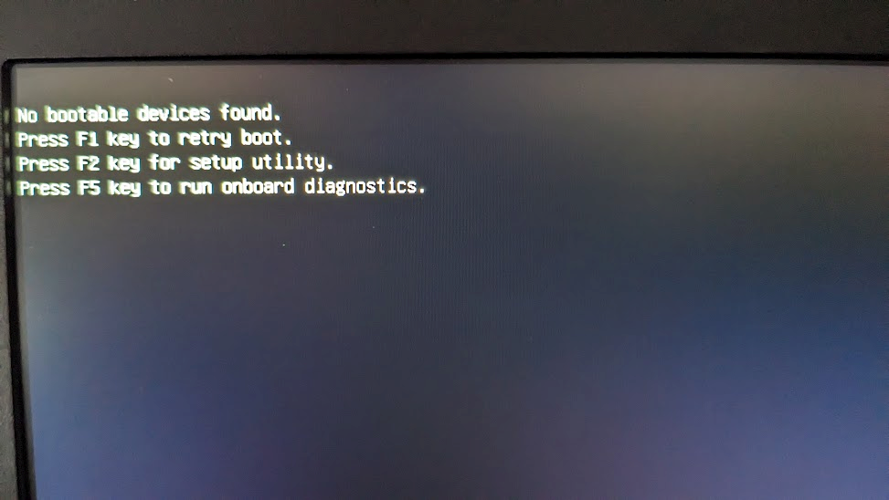

First, reboot the laptop by pressing the CTRL-ALT-DEL keys at the same time.

You will then see the Dell welcome screen. As soon as you see this Dell welcome screen, begin to press the F12 key. You can press it many times.



Pressing the F12 key will give you a “boot option menu”. If you have successfully pressed F12, you will see some yellow text in the upper right-hand corner that says “Preparing one-time boot menu”

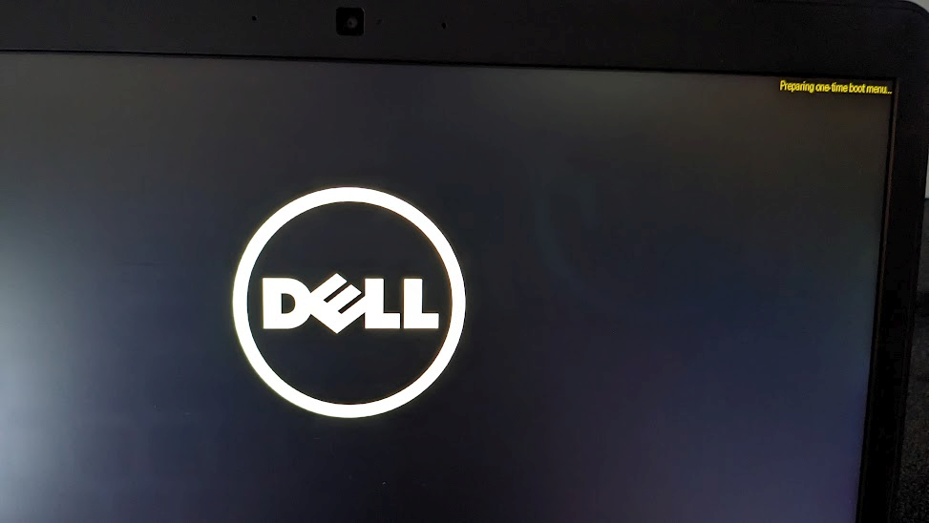

Then you will see the boot options window:

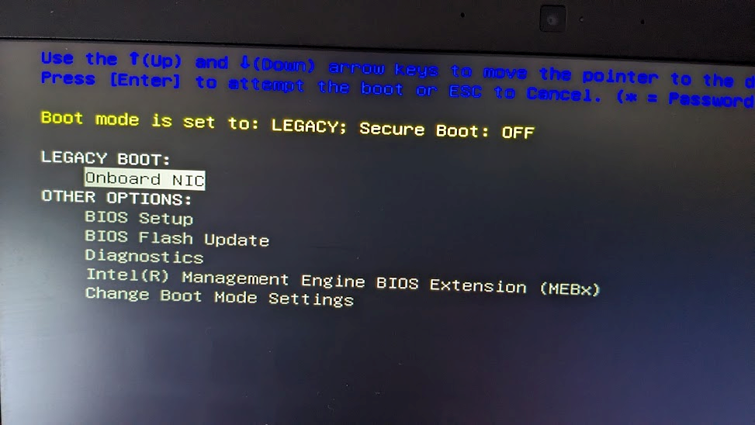

The option you want, “Onboard NIC”, should already be highlighted. Press the Enter key, and you should then get a successful boot.

**Summary:**

**F1**

**If boot not successful:**

**CTRL-ALT-DEL to reboot**

**Press F12 when you see Dell screen**

**Choose “Onboard NIC”**

Laptops that Need External Keyboard

There are two laptops (AS-1412 and AS-1445) that need an external keyboard. The extra keyboard is included in each school’s box for those laptops (Lucas Malia and Nkowe).

HP Laptops (Kibroriloni and Ifati)

If you start an HP laptop and it doesn’t find something to boot to (for example, if you forgot to turn on the network switch), it will give a message about no bootable device.

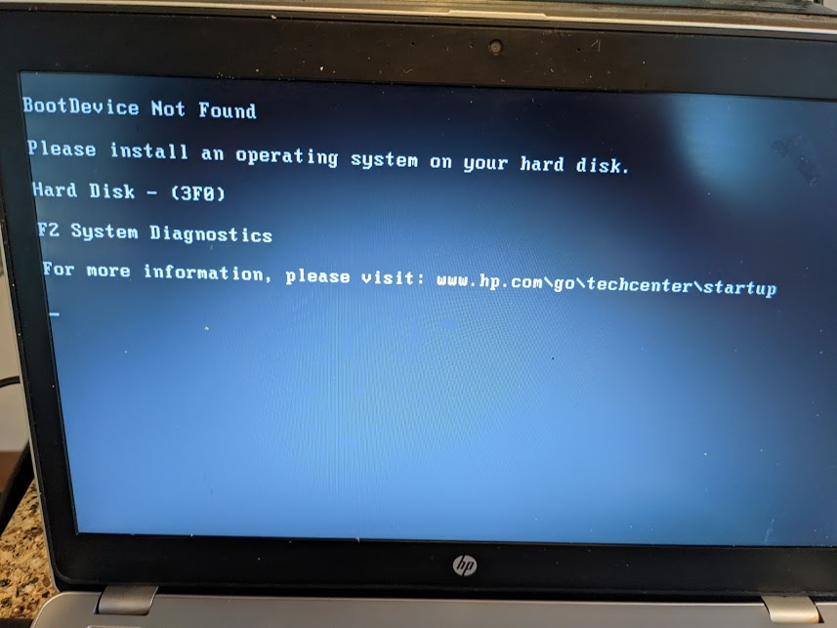

Then the next time you try to boot, it will take you to the HP Diagnostic Test. You then have to choose “Exit” and then “Yes” before it will try to boot again to the network.

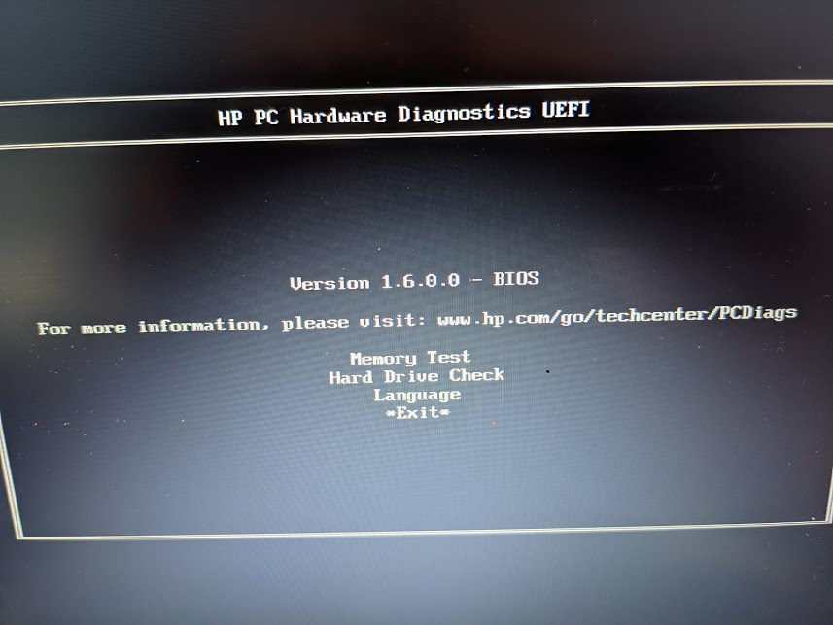 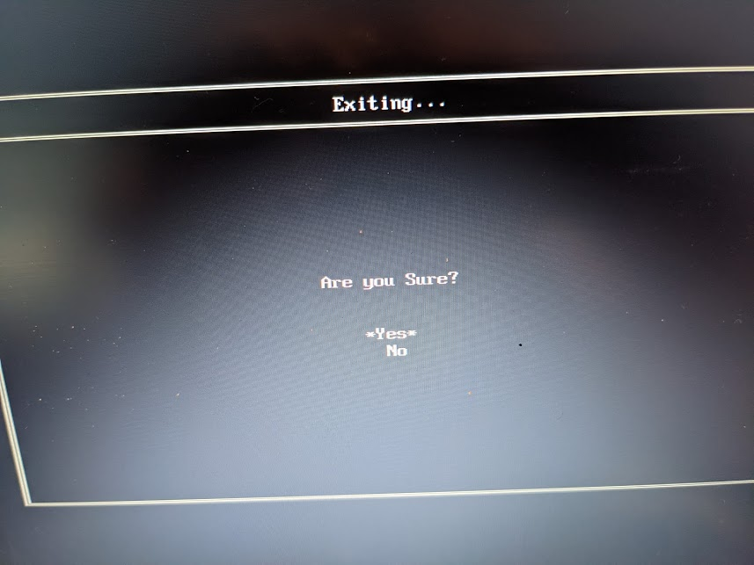

So for example if they forgot to turn the switch on, they will have to go through this “Exit” and “Yes” for any of the clients that were on and didn’t find something to boot to. Once you do “Exit” and “Yes”, the next time it will boot just fine. This is a hassle, but I couldn’t find a way to disable this. Please share this issue with the Super Users at Kiboriloni and Ifati), so they are not worried when they see it.

Laptop Security: Special Screw to prevent RAM theft

For the E7250, E7440, and E7450 computers in this shipment, there are two screws on the back that hold the back cover in place. For each of these laptops, I have replaced one of the regular screws with a “Torx 6” screw (see the picture below). A torx screw is like a 6-pointed star.

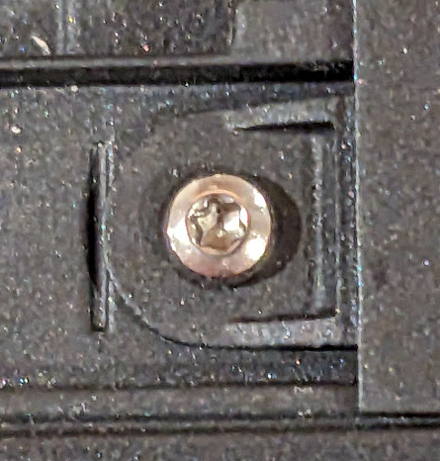

This special screw will hopefully stop people from stealing the RAM. You can use your Torx 6 screwdriver to remove the Torx 6 screw if you need to.

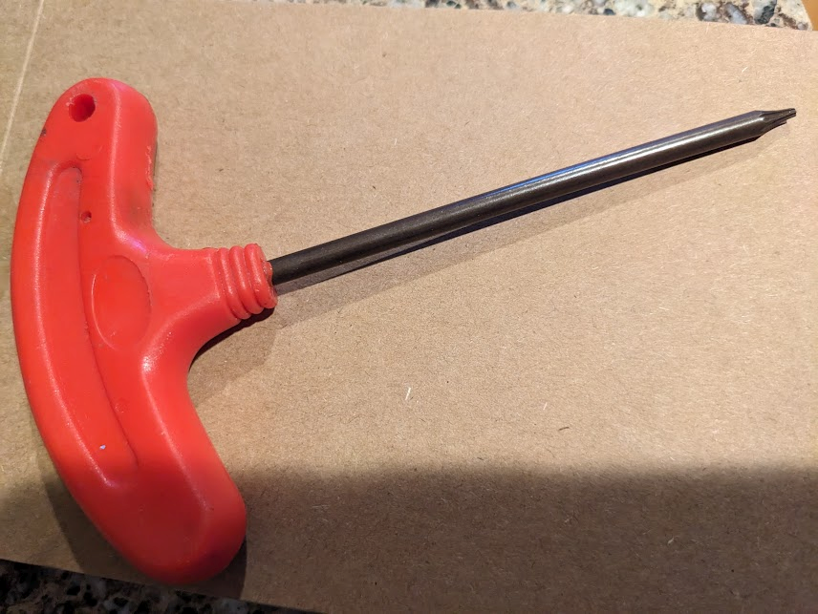

Laptop Security: Set Administrator Password so students cannot enter BIOS

I have set the administrator password on each of the Dell laptops in this shipment. It is set to:

**R3n3al@TZ**

This password locks the BIOS. If you need to change the BIOS, you will need to enter this password to unlock it.

When you set the administrator password for other laptops, it is very important that you use this same password, and be very careful that you have typed it in correctly.

**Box Contents**

|  |  |  |  |
| --- | --- | --- | --- |
| **Box** | **Item** | **Quantity** | **Destination** |
| A | Laptop | 8 | Lucas Malia |
| A | Laptop adapter | 20 | Lucas Malia |
| A | Mouse | 1 | Lucas Malia |
| A | Keyboard | 2 | Lucas Malia |
|  |  |  |  |
| **Box** | **Item** | **Quantity** | **Destination** |
| B | Laptop | 12 | Lucas Malia |
|  |  |  |  |
| **Box** | **Item** | **Quantity** | **Destination** |
| C | Laptop | 8 | Nkowe |
| C | Laptop adapter | 20 | Nkowe |
| C | Mouse | 1 | Nkowe |
| C | Keyboard | 2 | Nkowe |
|  |  |  |  |
| **Box** | **Item** | **Quantity** | **Destination** |
| D | Laptop | 12 | Nkowe |
|  |  |  |  |
| **Box** | **Item** | **Quantity** | **Destination** |
| E | Laptop | 8 | Hawa Mchopa |
| E | Laptop adapter | 20 | Hawa Mchopa |
| E | Mouse | 1 | Hawa Mchopa |
| E | Keyboard | 1 | Hawa Mchopa |
|  |  |  |  |
| **Box** | **Item** | **Quantity** | **Destination** |
| F | Laptop | 12 | Hawa Mchopa |
|  |  |  |  |
| **Box** | **Item** | **Quantity** | **Destination** |
| G | Laptop | 8 | Ruangwa |
| G | Laptop adapter | 20 | Ruangwa |
| G | Mouse | 1 | Ruangwa |
| G | Keyboard | 1 | Ruangwa |
|  |  |  |  |
| **Box** | **Item** | **Quantity** | **Destination** |
| H | Laptop | 12 | Ruangwa |
|  |  |  |  |
| **Box** | **Item** | **Quantity** | **Destination** |
| I | Laptop | 8 | Mbekenyera |
| I | Laptop adapter | 20 | Mbekenyera |
| I | Mouse | 1 | Mbekenyera |
| I | Keyboard | 1 | Mbekenyera |
|  |  |  |  |
| **Box** | **Item** | **Quantity** | **Destination** |
| J | Laptop | 12 | Mbekenyera |
|  |  |  |  |
| **Box** | **Item** | **Quantity** | **Destination** |
| K | Laptop | 8 | Butiama |
| K | Laptop adapter | 20 | Butiama |
| K | Mouse | 1 | Butiama |
| K | Keyboard | 1 | Butiama |
|  |  |  |  |
| **Box** | **Item** | **Quantity** | **Destination** |
| L | Laptop | 12 | Butiama |
|  |  |  |  |
| **Box** | **Item** | **Quantity** | **Destination** |
| M | Laptop | 8 | Butuguri |
| M | Laptop adapter | 20 | Butuguri |
| M | Mouse | 1 | Butuguri |
| M | Keyboard | 1 | Butuguri |
|  |  |  |  |
| **Box** | **Item** | **Quantity** | **Destination** |
| N | Laptop | 12 | Butuguri |
|  |  |  |  |
| **Box** | **Item** | **Quantity** | **Destination** |
| O | Laptop | 8 | Kiabakari |
| O | Laptop adapter | 20 | Kiabakari |
| O | Mouse | 1 | Kiabakari |
| O | Keyboard | 2 | Kiabakari |
|  |  |  |  |
| **Box** | **Item** | **Quantity** | **Destination** |
| P | Laptop | 12 | Kiabakari |
|  |  |  |  |
| **Box** | **Item** | **Quantity** | **Destination** |
| Q | Laptop | 10 | Kiagata |
| Q | Laptop adapter | 10 | Kiagata |
| Q | Mouse | 1 | Kiagata |
| Q | Keyboard | 1 | Kiagata |
|  |  |  |  |
| **Box** | **Item** | **Quantity** | **Destination** |
| R | Laptop | 10 | Kiagata |
| R | Laptop adapter | 10 | Kiagata |
|  |  |  |  |
| **Box** | **Item** | **Quantity** | **Destination** |
| S | Laptop | 10 | Bumangi |
| S | Laptop adapter | 10 | Bumangi |
| S | Mouse | 1 | Bumangi |
| S | Keyboard | 1 | Bumangi |
|  |  |  |  |
| **Box** | **Item** | **Quantity** | **Destination** |
| T | Laptop | 10 | Bumangi |
| T | Laptop adapter | 10 | Bumangi |
|  |  |  |  |
| **Box** | **Item** | **Quantity** | **Destination** |
| U | Laptop | 10 | Kiboriloni |
| U | Laptop adapter | 10 | Kiboriloni |
| U | Mouse | 1 | Kiboriloni |
| U | Keyboard | 1 | Kiboriloni |
|  |  |  |  |
| **Box** | **Item** | **Quantity** | **Destination** |
| V | Laptop | 10 | Kiboriloni |
| V | Laptop adapter | 10 | Kiboriloni |
|  |  |  |  |
| **Box** | **Item** | **Quantity** | **Destination** |
| W | Laptop | 10 | Ifati |
| W | Laptop adapter | 10 | Ifati |
| W | Mouse | 1 | Ifati |
| W | Keyboard | 1 | Ifati |
|  |  |  |  |
| **Box** | **Item** | **Quantity** | **Destination** |
| X | Laptop | 10 | Ifati |
| X | Laptop adapter | 10 | Ifati |
|  |  |  |  |
| **Box** | **Item** | **Quantity** | **Destination** |
| AA | Desktop computer | 1 | Lucas Malia |
| AA | Desktop computer | 1 | Nkowe |
| AA | Network switch, 24-port | 1 | Lucas Malia |
| AA | Network switch, 24-port | 1 | Nkowe |
| AA | System admin manual | 1 | Lucas Malia |
| AA | System admin manual | 1 | Nkowe |
|  |  |  |  |
|  |  |  |  |
|  |  |  |  |
|  |  |  |  |
|  |  |  |  |
|  |  |  |  |
|  |  |  |  |
| **Box** | **Item** | **Quantity** | **Destination** |
| BB | Desktop computer | 1 | Hawa Mchopa |
| BB | Desktop computer | 1 | Ruangwa |
| BB | Network switch, 24-port | 1 | Hawa Mchopa |
| BB | Network switch, 24-port | 1 | Ruangwa |
| BB | System admin manual | 1 | Hawa Mchopa |
| BB | System admin manual | 1 | Ruangwa |
|  |  |  |  |
| **Box** | **Item** | **Quantity** | **Destination** |
| CC | Desktop computer | 1 | Mbekenyera |
| CC | Desktop computer | 1 | Butiama |
| CC | Network switch, 24-port | 1 | Mbekenyera |
| CC | Network switch, 24-port | 1 | Butiama |
| CC | System admin manual | 1 | Mbekenyera |
| CC | System admin manual | 1 | Butiama |
|  |  |  |  |
| **Box** | **Item** | **Quantity** | **Destination** |
| DD | Desktop computer | 1 | Butuguri |
| DD | Desktop computer | 1 | Kiabakari |
| DD | Network switch, 24-port | 1 | Butuguri |
| DD | Network switch, 24-port | 1 | Kiabakari |
| DD | System admin manual | 1 | Butuguri |
| DD | System admin manual | 1 | Kiabakari |
|  |  |  |  |
| **Box** | **Item** | **Quantity** | **Destination** |
| EE | Desktop computer | 1 | Kiagata |
| EE | Network switch, 24-port | 1 | Kiagata |
| EE | System admin manual | 1 | Kiagata |
| EE | Desktop computer | 1 | Bumangi |
| EE | Network switch, 24-port | 1 | Bumangi |
| EE | System admin manual | 1 | Bumangi |
|  |  |  |  |
| **Box** | **Item** | **Quantity** | **Destination** |
| FF | Desktop computer | 1 | Kiboriloni |
| FF | Network switch, 24-port | 1 | Kiboriloni |
| FF | System admin manual | 1 | Kiboriloni |
| FF | Desktop computer | 1 | Ifati |
| FF | Network switch, 24-port | 1 | Ifati |
| FF | System admin manual | 1 | Ifati |
|  |  |  |  |
|  |  |  |  |
| **Box** | **Item** | **Quantity** | **Destination** |
| GG | Monitor | 4 | Lucas Malia, Nkowe, Hawa Mchopa, Ruangawa |
| GG | VGA cable | 4 | Lucas Malia, Nkowe, Hawa Mchopa, Ruangawa |
| GG | Power cable | 4 | Lucas Malia, Nkowe, Hawa Mchopa, Ruangawa |
|  |  |  |  |
|  |  |  |  |
| **Box** | **Item** | **Quantity** | **Destination** |
| HH | Monitor | 4 | Mbekenyera, Butiama, Butuguri, Kiabakari |
| HH | VGA cable | 4 | Mbekenyera, Butiama, Butuguri, Kiabakari |
| HH | Power cable | 4 | Mbekenyera, Butiama, Butuguri, Kiabakari |
|  |  |  |  |
|  |  |  |  |
| **Box** | **Item** | **Quantity** | **Destination** |
| II | Monitor | 4 | Kigata, Bumangi, Kiboriloni, Ifati |
| II | VGA cable | 4 | Kigata, Bumangi, Kiboriloni, Ifati |
| II | Power cable | 4 | Kigata, Bumangi, Kiboriloni, Ifati |
|  |  |  |  |
|  |  |  |  |
| **Box** | **Item** | **Quantity** | **Destination** |
| JJ | Monitor | 4 | Spares |
| JJ | VGA cable | 4 | Spares |
| JJ | Power cable | 4 | Spares |
|  |  |  |  |
|  |  |  |  |
| **Box** | **Item** | **Quantity** | **Destination** |
| KK | Monitor | 2 | Spares |
| KK | VGA cable | 2 | Spares |
| KK | Power cable | 2 | Spares |
| KK | Keyboards | 3 | Spares |
| KK | Team Supplies | 1 | Box |